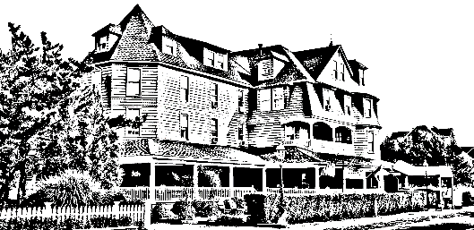

Valentines Day Brunch Buffet

Saturday February 14th

Shrimp Cocktail Display

Assorted Breakfast Breads

Served in Chaffers

Stuffed French Toast

Waffles

Bacon & Sausage

Roasted Potatoes
Sautéed Vegetables
Chicken Francaise
Penne Vodka
Seabass with Assorted Shellfish
Taco Station

Mixed green Salad/Caesar Salad

Mixed Green Salad with an Orange Shallot Dressing or Caesar Salad is upon request.

Build Your Own Omelet
Choice of Eggs or Egg Whites
With traditional Accompaniments
Eggs Benedict
Pancakes
Chocolate Fountain/Assorted Desserts
Ice Cream Station
$40.00 per adult & $20.00 per child includes soft drinks, coffee, tea, and juices
*This does not include tax, gratuity

