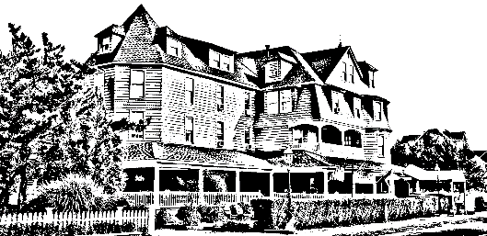
The Grenville
Hotel & Restaurant

Easter Day

Shrimp Cocktail
Omelet Station with traditional fixing
Stuffed French Toast/ Waffles
Bacon/ Sausage
Roasted Potatoes/ Sautéed Vegetables
Chicken Francaise
Swedish Meatballs
Penne Vodka
Eggplant Rollatini
Sausage & Peppers
Seafood Ensemble: Sea bass, Mussels, Clams, Shrimp
Carving Station: Ham, Stuffed Pork Loin
Caesar Salad/ Mixed Green Salad

Assorted Bread Basket
Assorted Desserts

$60.00 per adult & $35.00 per child
*This does not include tax, gratuity or beverages

Please let your server know if there are any food allergies or if you do not prefer one of the entrees included in the platter.

