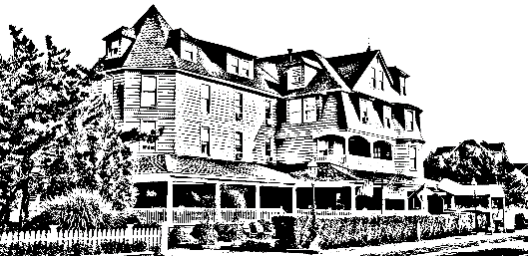

Sunday Brunch

*The Grenville*

*Hotel & Restaurant*

Assorted Breakfast Breads

Served in Chaffers

Stuffed French Toast

Waffles

Bacon & Sausage

Roasted Potatoes

Sautéed Vegetables

Chicken Francaise

Penne Vodka

Seabass with Assorted Shellfish

Mixed green Salad/Caesar Salad

*Mixed Green Salad with an Orange Shallot Dressing or Caesar Salad is upon request.*

Build Your Own Omelet

*Choice of Eggs or Egg Whites*

*With traditional Accompaniments*

Eggs Benedict

$24.99 per adult & $19.99 per child

*\*This does not include tax, gratuity or beverages*

*Please let your server know if there are any food allergies or if you do not prefer one of the entrees included in the platter.*