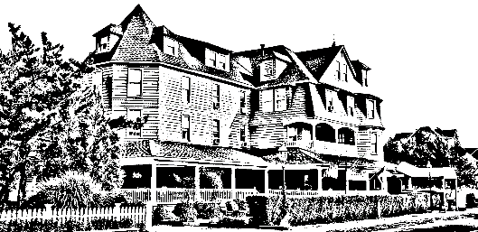

Brunch with the Bunny
The Grenville
345 Main Ave
Bay Head NJ
Saturday March 28th
10:00am

Assorted Breakfast Breads & Pastries

Chef Attended Omelet Station
Pancakes

Bacon/Sausage
Waffles/Stuffed French Toast
Chicken Fingers and French Fries
Macaroni and Cheese
Seafood Ensemble
Roasted Potatoes/Vegetables
Swedish Meatballs
Chicken Francais
Caesar Salad/Mixed Green Salad

Unlimited coffee, tea, soft drinks, juices
Ice Cream Station
Assorted Desserts/Chocolate Fountain
$45 adults/$30 children
Excludes tax and gratuity
**Call for Reservations**
732-892-3100

