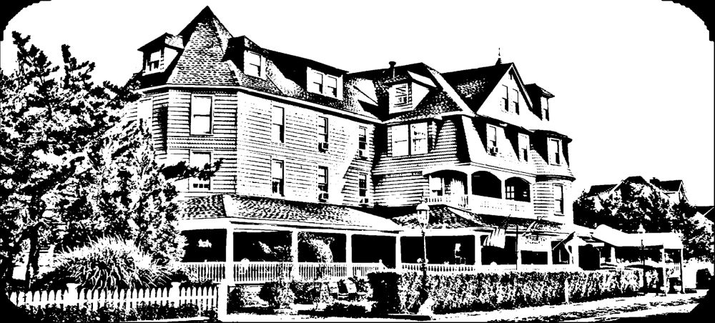
Father’s Day
Chef attended omelet station with traditional fixings
Stuffed French Toast
Belgian Waffles
Bacon & Sausage
Roasted Potatoes/Vegetables
Scrambled Eggs
Penne Vodka
Taco Bar
Seafood Ensemble
Sauteed Vegetables/Corn on Cobb
Fried Chicken: BBQ sauce on side
CARVING STATION:
Ribs and Stuffed Pork Loin
Caesar Salad or Mixed Green Salad

Assortment of Finger Desserts & Fresh Fruit
**Includes Beverages**
$45.00 per adult $35.00 per Child (5 years of age to 14 years old)

