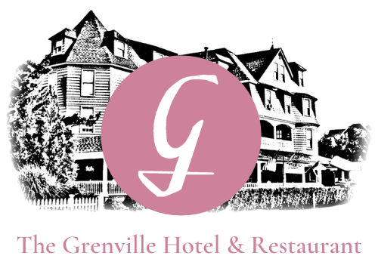
Dinner Menu
Please Let your server know if you have any food allergies
Appetizers
Fried Calamari
Served with Traditional Marinara Sauce $15.95

Crab and Avocado Tower
Crab Salad Topped with Avocado, Mango, & Grilled Shrimp $15.95

Francaised Roasted Artichoke Hearts
Topped with Hudson Valley Goat Cheese $14.95

Mediterranean Shrimp
Sautéed in Garlic, Spinach, & Feta Served with Pita Bread $15.95

Salads & Soups
Roasted Beet Salad
Field Greens, Beets, Crumbled Goat Cheese, with a Caramelized Orange Shallot Dressing $14.95
Mediterranean Salad
Chickpeas, Feta Cheese, Olives, Garlic, Shredded Romaine Lettuce with a White Balsamic Vinegar
& Extra Virgin Olive Oil Dressing $13.95

French Onion Soup $8.95
Soup Du Jour $8.95

Entrees
Pan Seared Wild North Atlantic Salmon
Served with a Rosemary Citrus Sauce Over a Wild Rice Pilaf $32.95
Artichoke Encrusted Seabass
A Lemon Beurre Blanc Sauce Served with Pistachio-Encrusted Whipped Potatoes
& sautéed Baby Spinach $28.95

Lump Crab Cakes
Lump Crab Meat, Served with a Caper Remoulade & Whipped Potatoes $29.95
Seafood Risotto
Risotto Pilaf, Crab Meat Topped with Caramelized Shrimp & Scallops
*Choice of Light or Traditional Creamy Sauce* $39.95
Add Lobster Tail- $16.95

Seafood Ensemble
Clams, Mussels, Shrimp, Scallops, and Seabass
Over Pasta or Rice
Choice of Red or White Sauce
$39.95

Filet Mignon
Grilled with Roasted Beets & a Truffle Reduction $39.95
Add Lobster Tail- $16.95

Grilled New York Strip
Served with Mashed Potatoes, Mixed Vegetables, &
A Side of Mushroom Reduction $35.95

Rack of Lamb
Drizzled with Our House Made Honey Mustard $34.95
Grenville Chicken Napoleon
Pan Seared Chicken Breast Layered with Spinach, Roasted Red Peppers, Grilled Zucchini, &
Mozzarella Cheese with a Marsala Wine Sauce $28.95

Pan Seared Ahi Tuna
Blackened & Topped with a Sweet Mango Medley Served Over Quinoa $31.95

Pasta
Fusilli A La Vodka
Served with Our Famous Vodka Sauce $26.95
*add Chicken $5.95 │ *add Shrimp $9.95

Seafood Tagliolini
Served with Shrimp, Scallops, Lemon, Olives, and Tomatoes in a White Wine Sauce $32.95

Tortellini Alfredo $28.95

***Ask you server about Gluten Free Options***

